Robin Mehta (robimeht)

AI Homework 6

***Answers = highlighted

***Work shown = images

**Exercise 1: k-NN Regression**

**1. Predict f[(3,2)]**

1-NN = 30

2-NN = 25

3-NN = 15

4-NN = 12

Work:

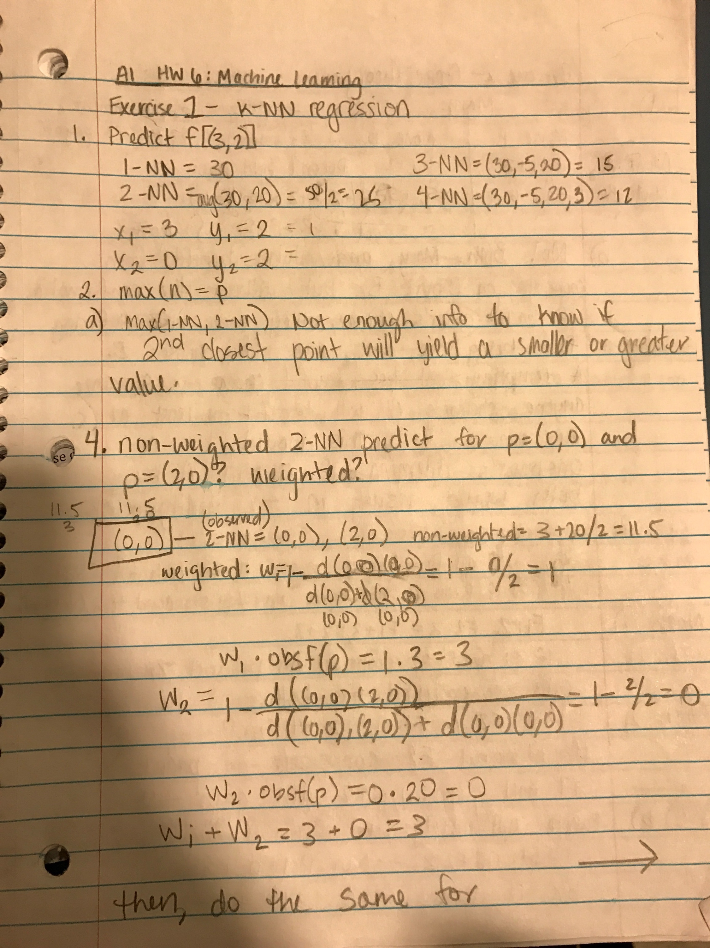

**2. Which predicts the greater value for p?**

a) 1-NN or 2-NN?

1-NN

b) 2-NN or 3-NN?

Not enough information because we don’t know the values of the 2nd and 3rd predicted points.

c) 1-NN or n-NN (n>1)?

1-NN

d) 2-NN or n-NN (n>2)?

Not enough information because we don’t know the values of the 2nd or next n predicted points.

**3. Describe the set of all points whose predicted values under weighted 2-NN are exactly the same as those for non-weighted 2-NN. Observed points: (0,0) and (2,0).**

All points on line x=1

**4. What values does non-weighted 2-NN predict for p=(0,0) and p=(2,0)? What values does weighted 2-NN predict?**

Non-weighted(0,0): 11.5

Weighted(0,0): 1 – 2/2 = 3

Non-weighted(2,0) = 11.5

Weighted(2,0) = 20

**Exercise 2: Game Theory**

**1. Mary & John deciding on Movie A or B.**

a) Payoff matrix:

|  |  |  |
| --- | --- | --- |
|  | Movie A | Movie B |
| Movie A | M(+2) J(+2) | M(-6) J(+2) |
| Movie B | M(+2) J(-6) | M(+5) J(+5) |

b) No, this is not a prisoner’s dilemma.

T = trade-off; R = reward; P = punishment; S = sucker’s payoff

T > R > P > S must hold true to be a prisoner’s dilemma. +2 > +2 > +5 > -6 is false.

Both Mary and John benefit most from cooperating on Movie B, but without the confirmation of each other’s choice, they each risk suffering from being the only one to choose Movie B. A tempting choice is Movie A, since anyone choosing A will benefit at least at the minimum (+2). This could be a prisoner’s dilemma if choosing A by both would result in negative utility points.

**2. Two firms, product releases**

a) Nash equilibria: (F1X, F2Y)

b) Is that square Pareto optimal? If not, which squares are Pareto optimal?

(F1X, F2Y) is not Pareto optimal

(F1Z, F2Y), (F1Z, F2Z), and (F1Y, F2Y) are Pareto optimal.

**Exercise 3: Utility & Decision Theory**

**1. Draw a decision network. How much money is the information worth in expectation?**

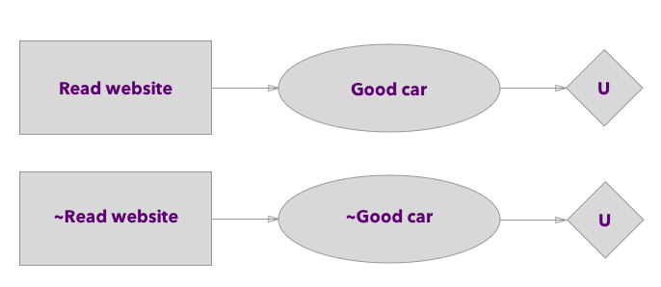

Expected Value(website) = (.8 * 1000) + (.2 * 5000) = $1800

Expected Value(no website) = (.5 * 1000) + (.5 * 5000) = $3000

The information is worth ($3000 - $1800) = **$1200** in expectation.

Work:

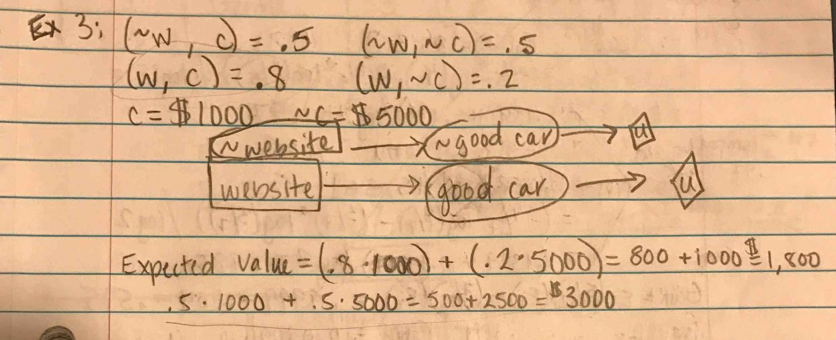

**Exercise 4: Neural Nets**

**1. Give the new weights of w1, w2, and w3 after one round of backpropagation with learning rate 0.05.**

w1 = .68

w2 = .4

w3 = .9

Work:

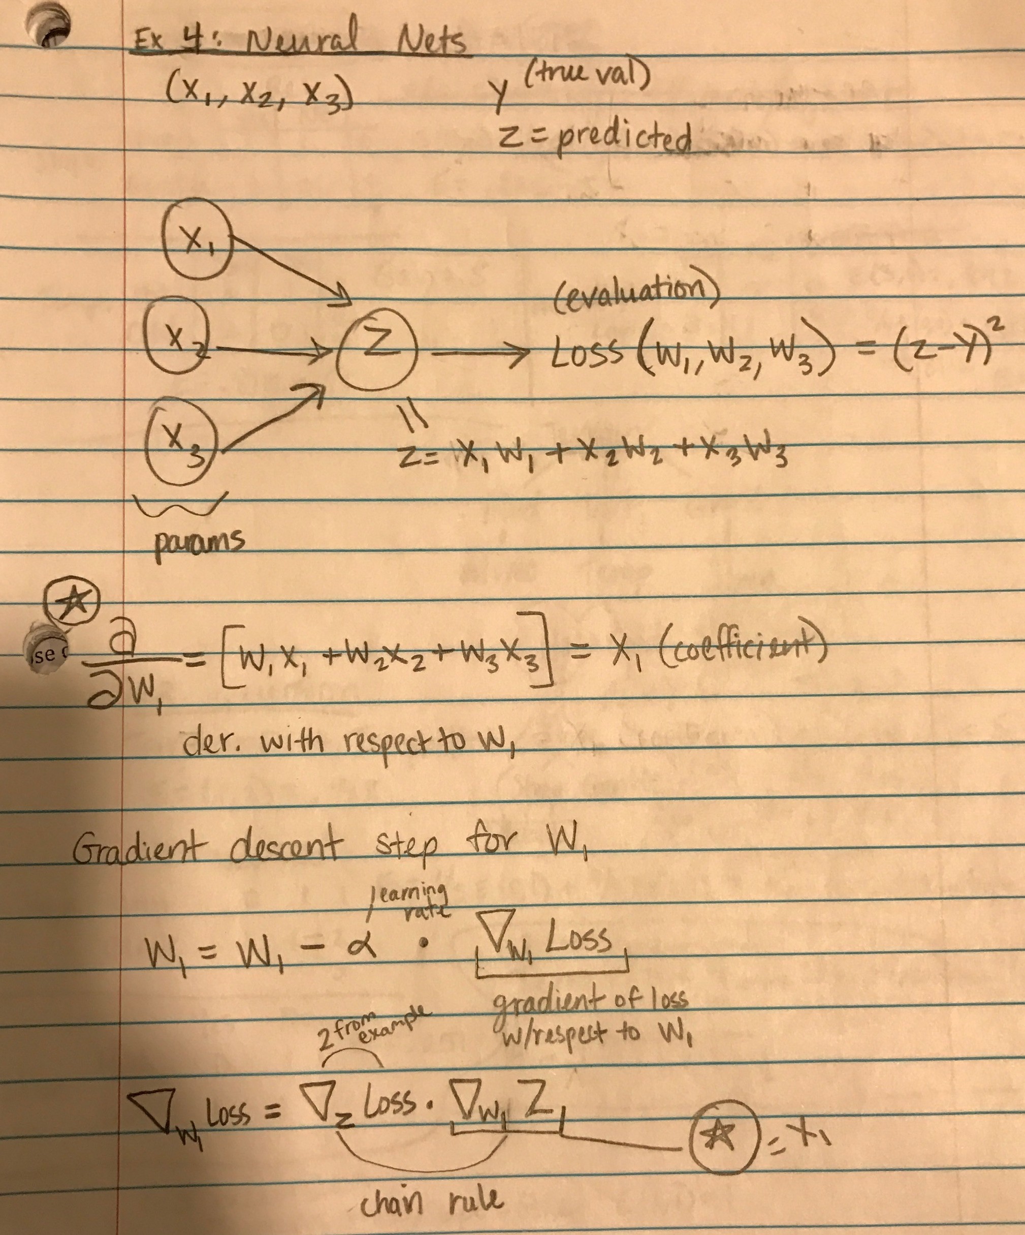

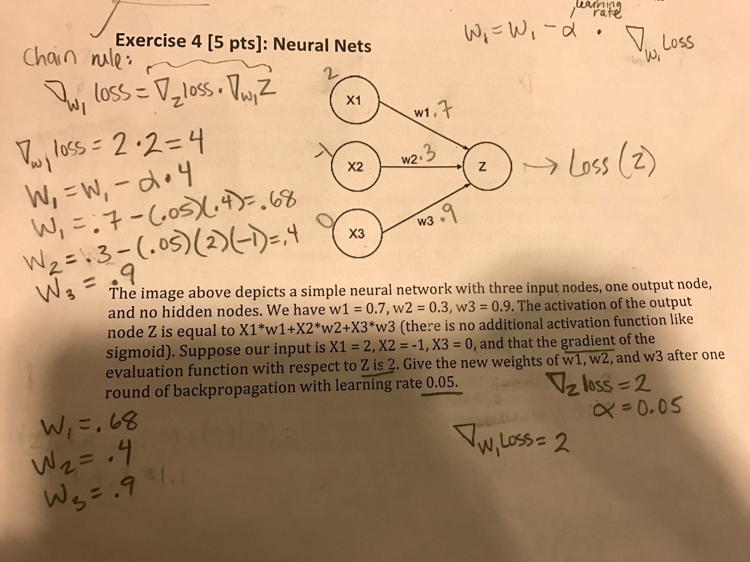

**Exercise 5: Decision Trees**

**1. How many distinct environments are possible?**

2 slopes * 3 terrains * 2 temps * 2 humidity = 24 distinct environments.

**2. Calculate the information gain on engine reliability of initially splitting on each slope, terrain, temperature, and humidity.**

Terrain: 0.37625

Humidity: 0.23674

Temperature: 0.072

Slope = 0.0215

Work:

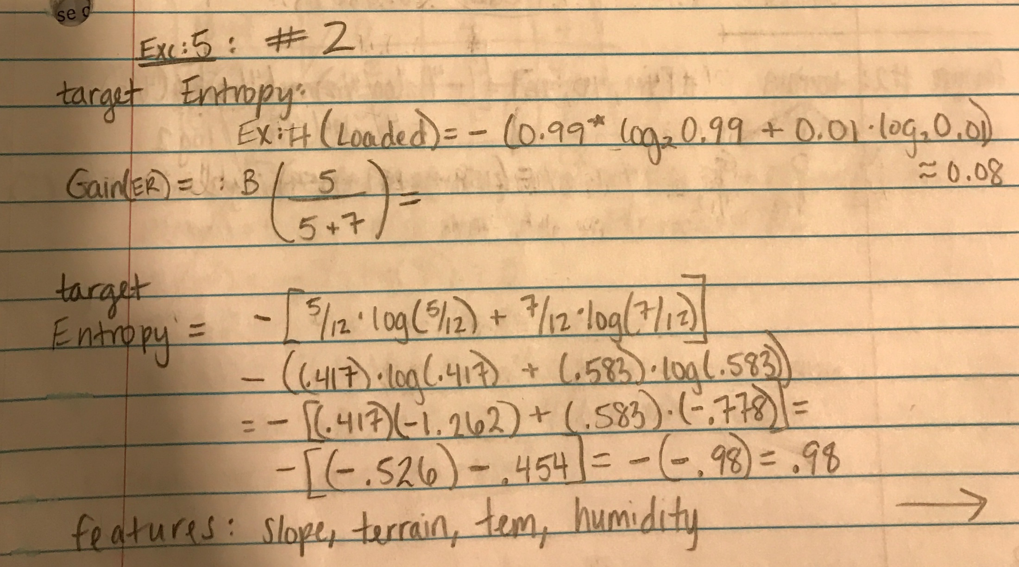

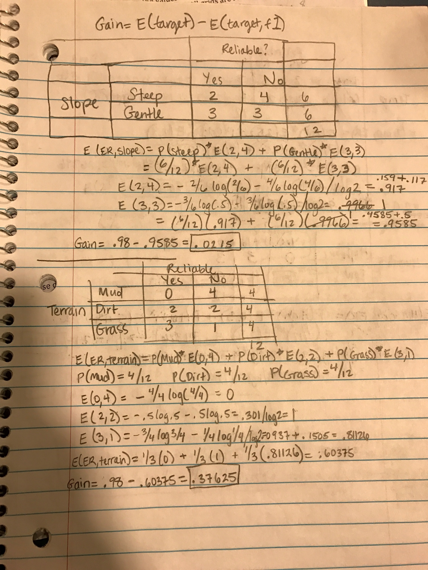

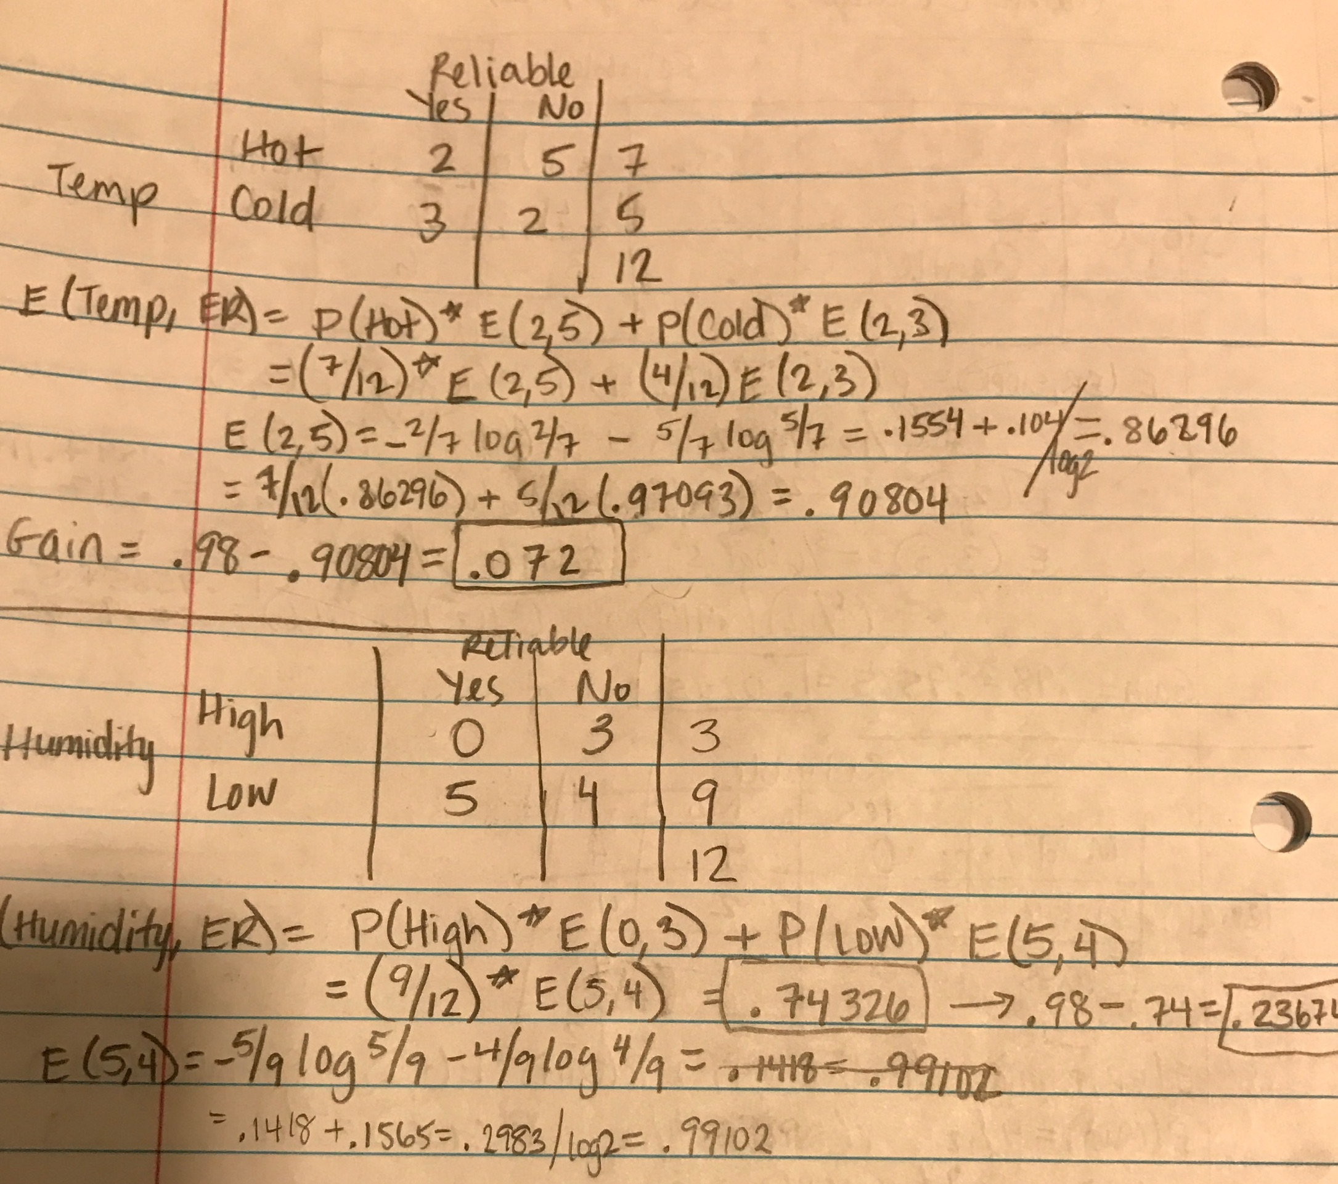

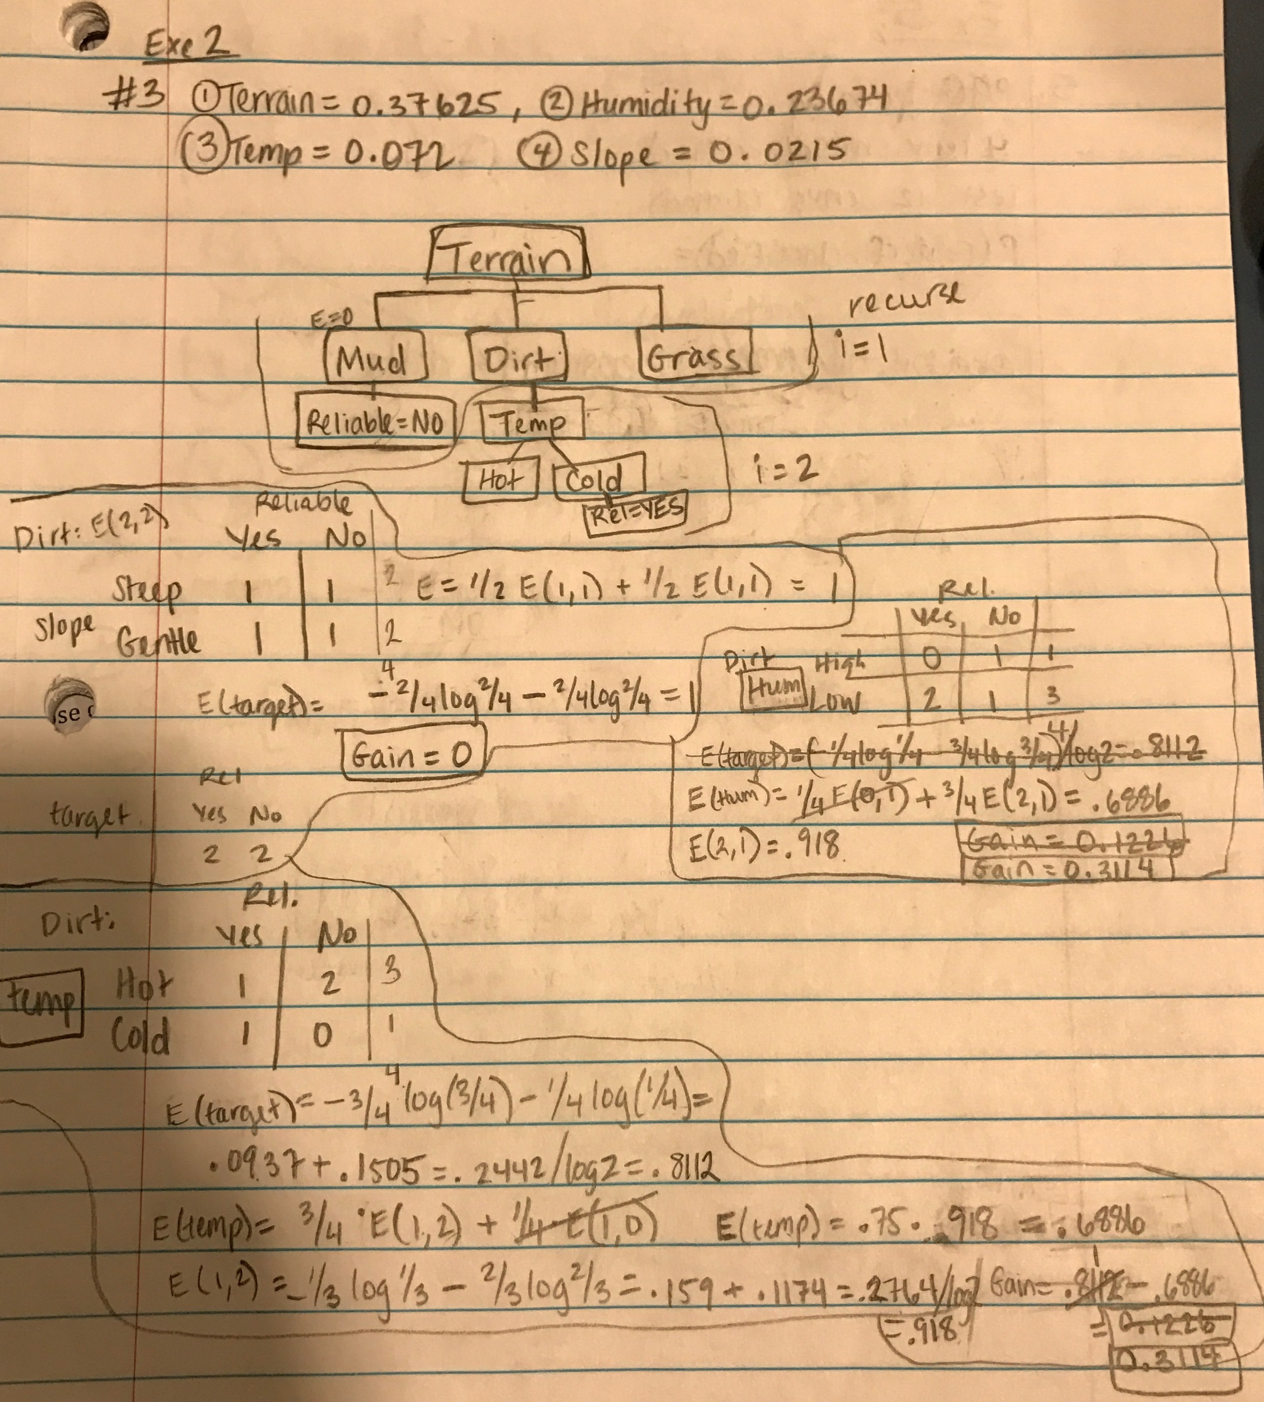

Recursive Step:

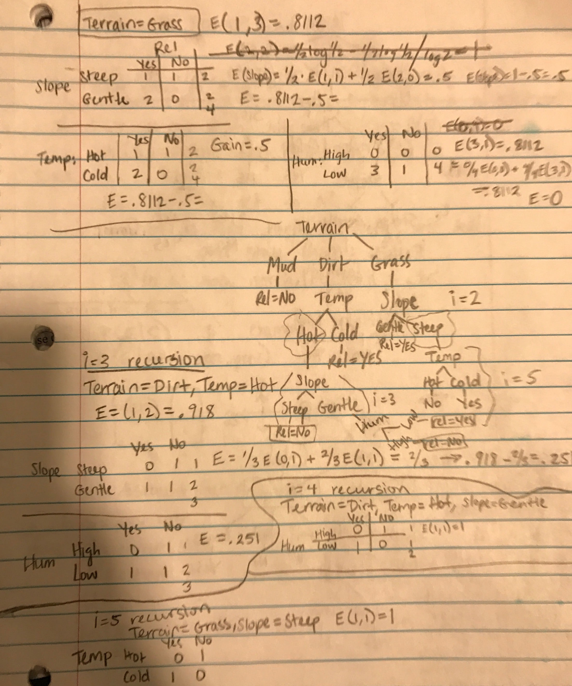

**3. Construct and draw the entire decision tree using max information gain to choose nodes at each level.**

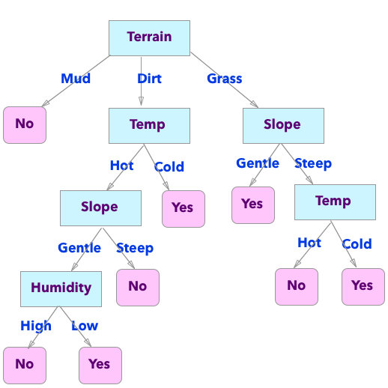

Work:

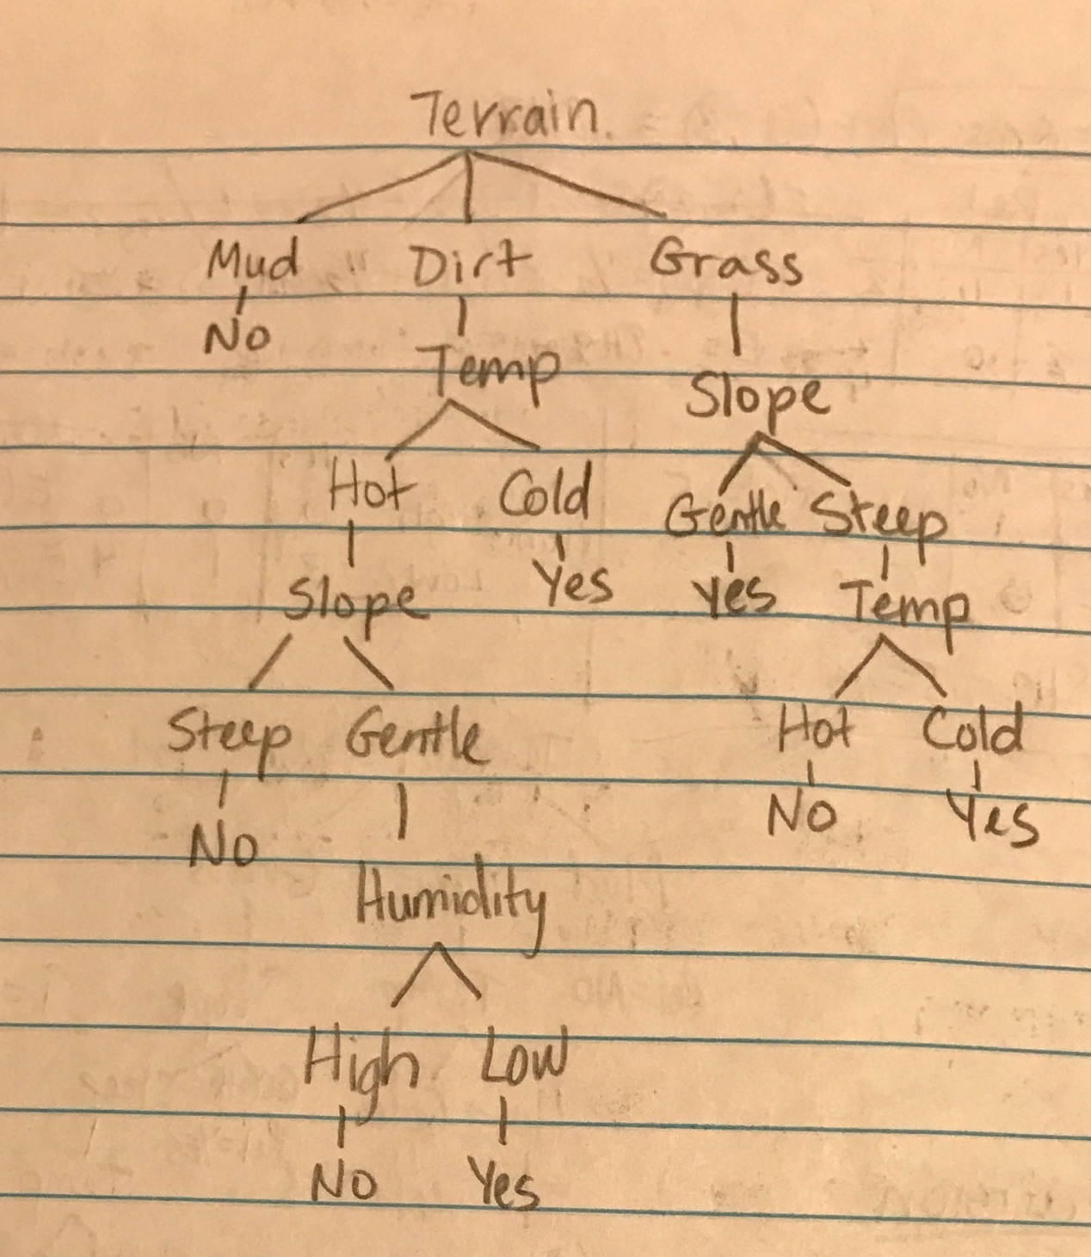

**4. Draw a different tree with 4 decision nodes that perfectly classifies engine reliability**

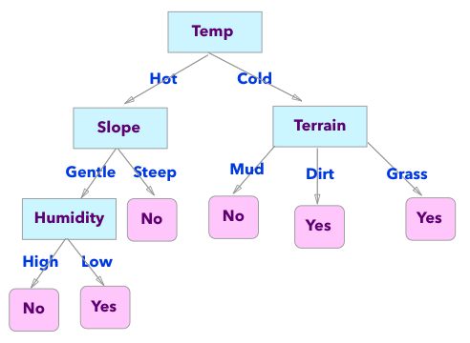

Work:

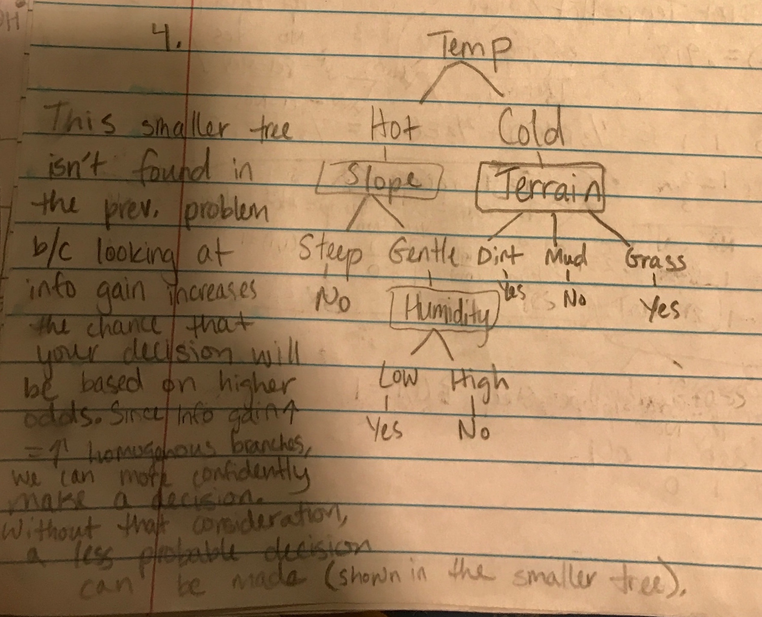

**5. What is the probability that T will perfectly classify all of the selected examples?**

Probability = Choose(20, 12) / Choose(24, 12)

= 125970 / 2704156

= 0.046584

**Exercise 6: POMDPs and MDPs**

**1. For each state, a, b, c, d, list the possible resulting states of going north starting in that state.**

State a:

a, c

State b:

b, c

State c:

a, b, c, d

State d:

d, c

**2. Calculate belief state after going north:**

**Goal a:**

Start a:

0.5*[north(0.7 * 1 * 0.2) + east(.1 * 1 * .2) + west(.1 * 1 * .2) + stay(.05 * 1 * .9)] = .1125

Start c:

0.25 [ north(0.7 * 1 * .9)] = .1575

= 0.1125 + 0.1575 = 0.27

**Goal b:**

Start b:

0.125*[north(0.7 * 1 * .2) + south(0.05 * 1 * .2) + west(0.1 * 1 * 0.2) + stay(0.05 * 1 * .9)] = .026875

Start c:

0.25*[east(0.1 * 0.9)] = 0.0225

= 0.026875 + 0.0225 = 0.049375

**Goal c:**

Start a:

0.5*[south(0.9 * 0.05)] = 0.0225

Start b:

0.125*[east(0.9 * .1)] = 0.01125

Start d:

0.125*[west(0.9 * .1)] = 0.01125

Start c:

0.25*[stay(0.9 * 0.05)] + south(0.2 * 0.05)] = 0.05875

**Goal d:**

Start d:

0.125*[north(0.7 * 1 * .2) + south(0.05 * 1 * .2) + east(0.1 * 1 * 0.2) + stay(0.05 * 1 * .9)] = .026875

Start c:

0.25*[west(0.1 * 0.9)] = 0.0225

= 0.026875 + 0.0225 = 0.049375

alpha = 0.4275

Initial belief state: <0.27, 0.049375, 0.05875, 0.049375>

Normalized belief state: <0.6316, 0.1155, 0.1375, 0.1155>

Work:

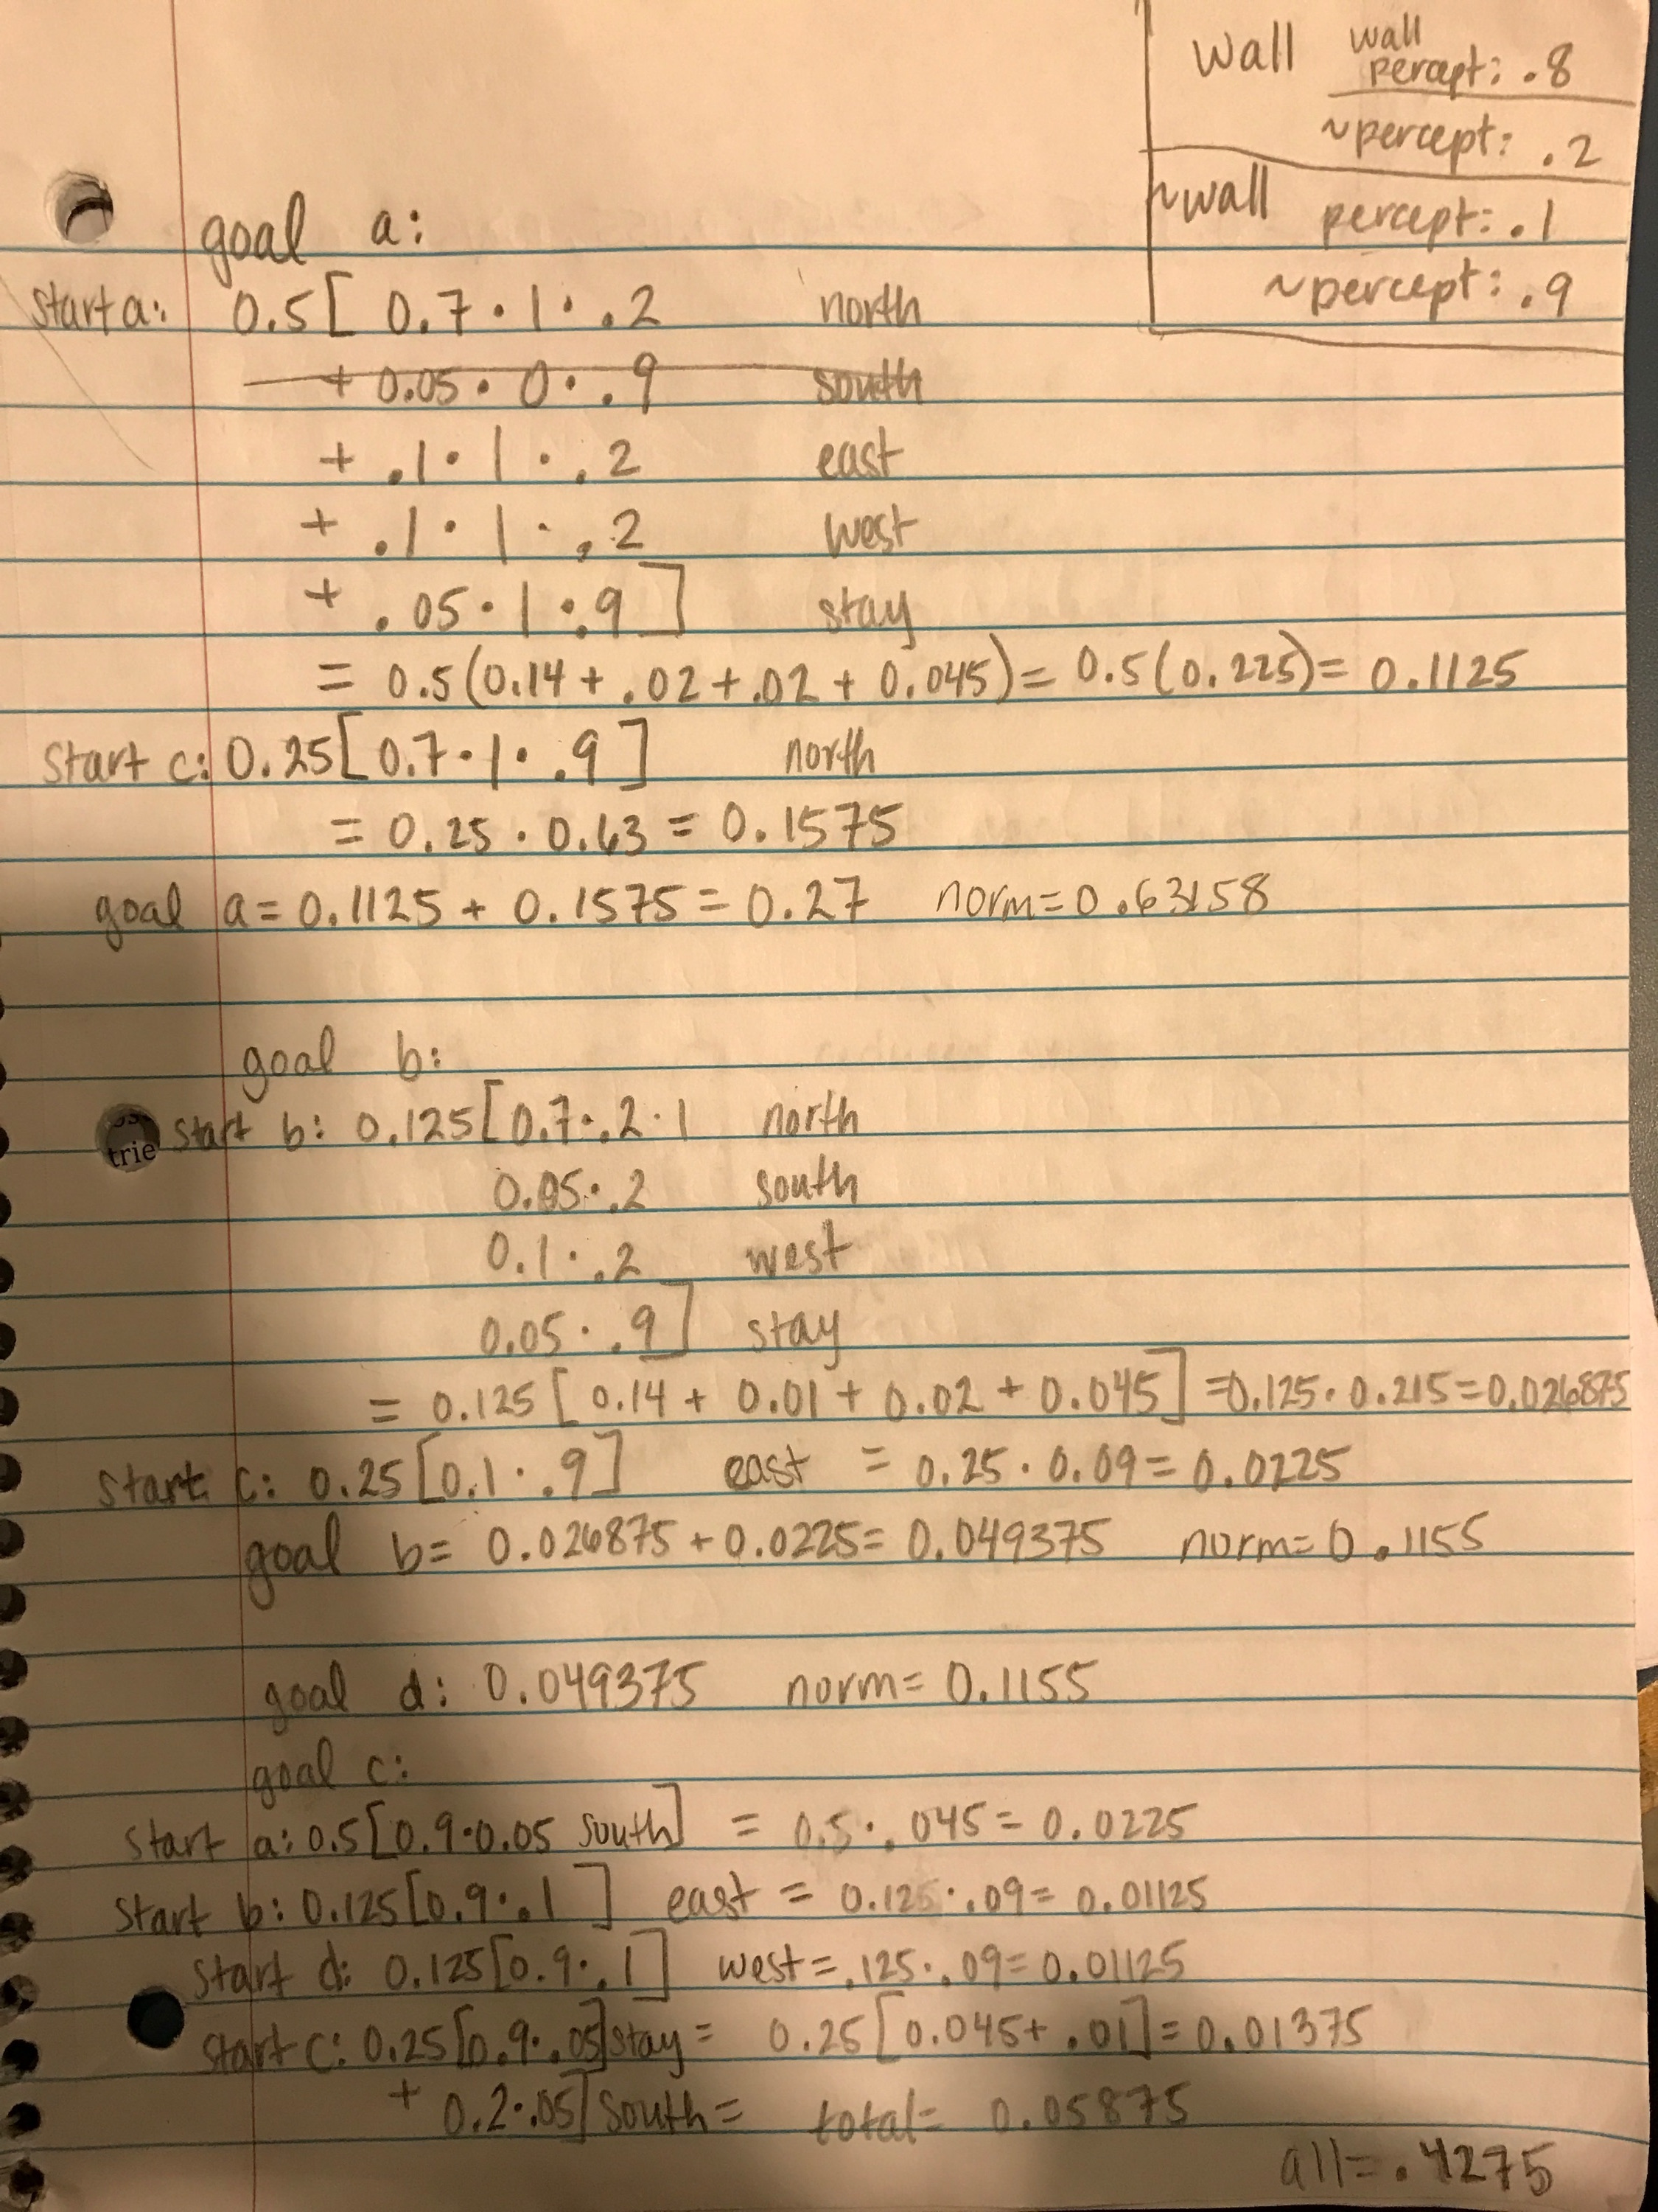

**3. Coding MDPs**

Run python robin_mehta_mdp.py testfile.txt

My code produces incorrect output. However, the logic seems sound.

Zhefan helped debug it, and Ryen looked over it, and I still couldn’t figure out the bug.

Output:

[[0.7297, 0.7992, 0.8774, 1.0],

[0.6797, 'x', 0.6244, -1.0],

[0.6234, 0.5734, 0.5502, 0.3335]]

If anyone can figure out why this code isn’t converging to the correct numbers, please let me know! I’m still curious.

Screenshot of main algorithm:

**Gamma = mult, reward = add, all other variables self-explanatory.

**Removed convergence code because code infinite loops. Not sure why!

Note: All code is appended at the end.

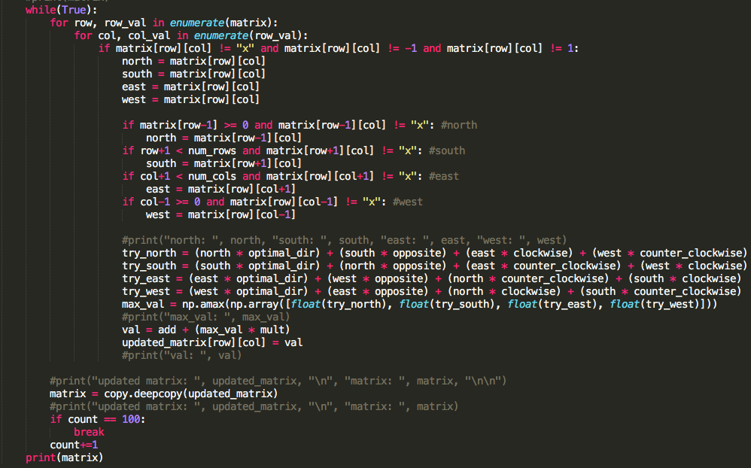

**Exercise 7: Linear Regression & Gradient Descent**

**1. Implement function exact_solution in regression.py**

Screenshot:

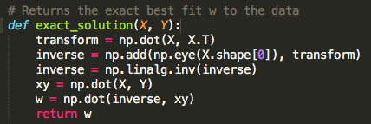

**2. Implement function gradient_descent in regression.py**

Screenshot:

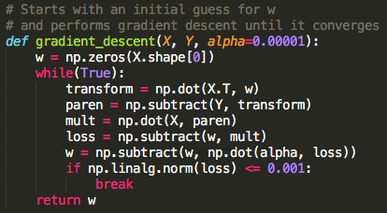

**3. Learn a model to predict the number of shares of an article given the features. What is the root mean squared error (rmse) and standard deviation? Does the linear model fit this data well? Why or why not? Which 5 features were most important to the model, according to the weights?**

Root mean squared error = 11594.7010699

Standard deviation 11626.8041057

-2.48910335443 , kw_min_min

-1.77846562306 , kw_avg_min

0.32035583568 , kw_max_avg

-0.30075797078 , kw_avg_avg

0.272368649134 , kw_max_min

0.175270323298 , num_hrefs

-0.158175770771 , num_self_hrefs

0.158108386742 , kw_min_avg

0.101698375506 , data_channel_is_lifestyle

0.101060927585 , self_reference_avg_sharess

0.097577356609 , data_channel_is_tech

0.0948516932657 , abs_title_subjectivity

0.0928313121419 , is_weekend

0.0927966335932 , self_reference_min_shares

0.0923656677283 , weekday_is_monday

0.0919024861678 , weekday_is_saturday

0.0914995751564 , LDA_03

0.0912512014273 , LDA_00

0.0907743661781 , LDA_04

0.0906044821084 , min_positive_polarity

0.0885161500676 , weekday_is_sunday

0.0879602322256 , global_subjectivity

0.0877267363812 , avg_positive_polarity

0.0876606180654 , max_positive_polarity

0.0875736816102 , global_rate_negative_words

0.0872578574587 , global_sentiment_polarity

0.0872040739461 , global_rate_positive_words

0.0871441332529 , min_negative_polarity

0.0868476853433 , rate_negative_words

0.0866901266358 , abs_title_sentiment_polarity

0.0855219651989 , weekday_is_friday

0.0854297711135 , n_non_stop_unique_tokens

0.0853247104195 , weekday_is_wednesday

0.0852146306404 , data_channel_is_socmed

0.0850249547405 , n_unique_tokens

0.0846668276774 , avg_negative_polarity

0.0832714243239 , weekday_is_thursday

0.0829714817466 , n_non_stop_words

0.0829150569661 , num_imgs

0.0828132567471 , n_tokens_title

0.0827224869284 , title_subjectivity

0.0819297303999 , rate_positive_words

0.0816141768271 , title_sentiment_polarity

0.0813487196037 , max_negative_polarity

0.0807475255885 , weekday_is_tuesday

0.0800795639694 , LDA_02

0.0789331651878 , num_keywords

0.0788688578602 , LDA_01

0.078303627987 , data_channel_is_world

0.0760345077338 , data_channel_is_entertainment

0.0733746202279 , num_videos

0.0728959932186 , data_channel_is_bus

0.0670116303407 , average_token_length

0.051552145364 , kw_avg_max

-0.0476890289303 , n_tokens_content

-0.0429924046456 , kw_min_max

-0.0187928937104 , kw_max_max

-0.00249235172393 , self_reference_max_shares

**RMSE is within 1 standard deviation, so the linear model does not fit this data well.** kw_min_min, kw_avg_min, kw_max_avg, kw_avg_avg, kw_max_min are the 5 features with the absval highest weights.

**Extra Credit:**

Code:

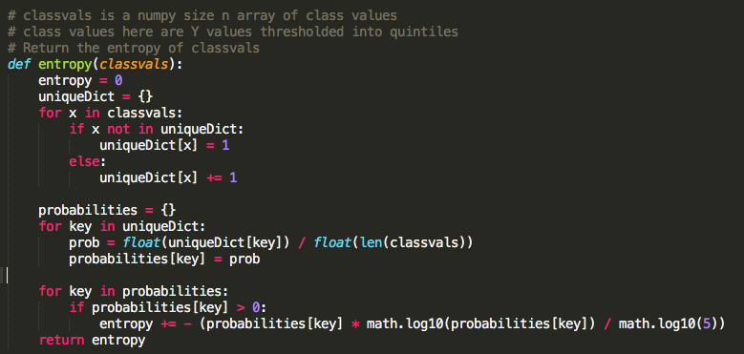

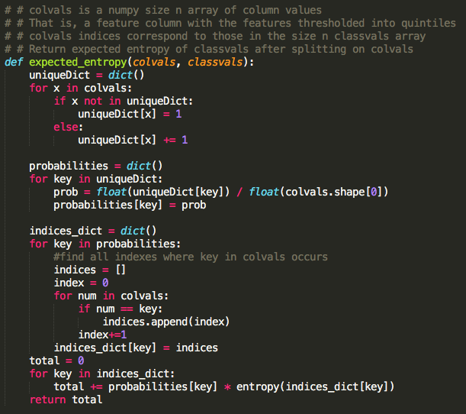

**Bin all numerical features into quintiles. Provide a table with the information gains from initially splitting on each feature.**

Entropy: 2.3219280792819137

LDA_02 , -4.57962448926

kw_avg_avg , -4.57962448926

global_sentiment_polarity , -4.57962448926

LDA_04 , -4.57962448926

global_subjectivity , -4.57962448926

LDA_01 , -4.57962448926

LDA_00 , -4.57962448926

LDA_03 , -4.57962448926

n_unique_tokens , -4.57962448926

kw_avg_max , -4.57962449124

kw_avg_min , -4.57962449519

average_token_length , -4.57962449519

global_rate_negative_words , -4.57962449519

n_non_stop_unique_tokens , -4.5796245031

global_rate_positive_words , -4.57962483121

kw_max_avg , -4.5796248846

avg_positive_polarity , -4.57962691067

n_tokens_content , -4.57963156729

self_reference_min_shares , -4.57963196391

avg_negative_polarity , -4.57964885228

self_reference_avg_sharess , -4.57965072364

self_reference_max_shares , -4.57967854536

n_non_stop_words , -4.57973163736

kw_max_min , -4.58127296161

rate_positive_words , -4.58178898762

rate_negative_words , -4.58207342018

min_negative_polarity , -4.58324609334

num_hrefs , -4.58831444075

num_self_hrefs , -4.60195699531

n_tokens_title , -4.61774941519

num_keywords , -4.62732825138

min_positive_polarity , -4.65878485708

max_negative_polarity , -4.6630827909

max_positive_polarity , -4.74297707232

kw_min_max , -4.76757163853

kw_min_avg , -4.76786673403

title_subjectivity , -4.78216625654

abs_title_sentiment_polarity , -4.81938559323

abs_title_subjectivity , -4.98447075017

kw_min_min , -5.00184019051

num_imgs , -5.01376477077

num_videos , -5.02209940492

title_sentiment_polarity , -5.02724778993

kw_max_max , -5.23857229788

data_channel_is_world , -5.25818447127

weekday_is_wednesday , -5.2797419746

weekday_is_tuesday , -5.28077857779

data_channel_is_tech , -5.28179724919

weekday_is_thursday , -5.28363896651

data_channel_is_entertainment , -5.28861518617

weekday_is_monday , -5.29832544473

data_channel_is_bus , -5.30866302754

weekday_is_friday , -5.32375208647

is_weekend , -5.3384703186

weekday_is_sunday , -5.42357796639

weekday_is_saturday , -5.43541409818

data_channel_is_socmed , -5.44101201147

data_channel_is_lifestyle , -5.45094571701

**Which 5 features provided the most information about the number of shares?**

LDA_02 , -4.57962448926

kw_avg_avg , -4.57962448926

global_sentiment_polarity , -4.57962448926

LDA_04 , -4.57962448926

global_subjectivity , -4.57962448926

**Are any of these the same as the 5 most important features in linear regression?**

kw_avg_avg is one of the same 5 most important features.

**APPENDED CODE:**

MDP PROBLEM:

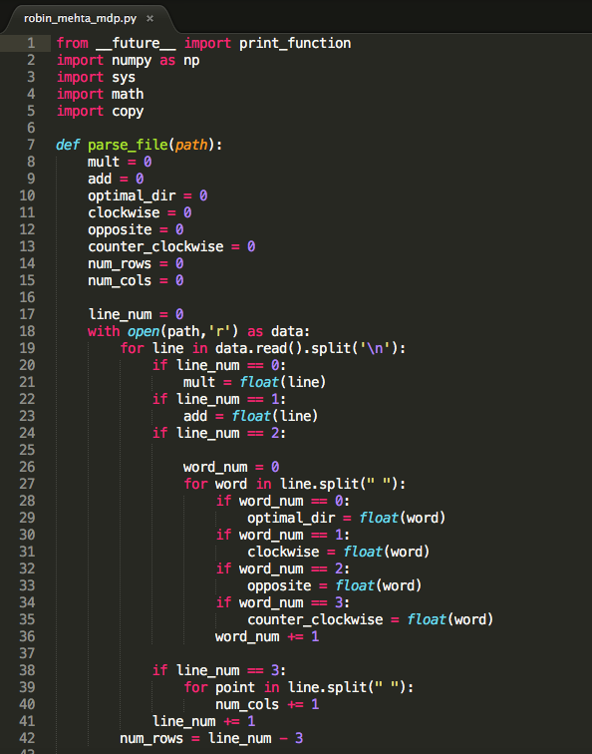

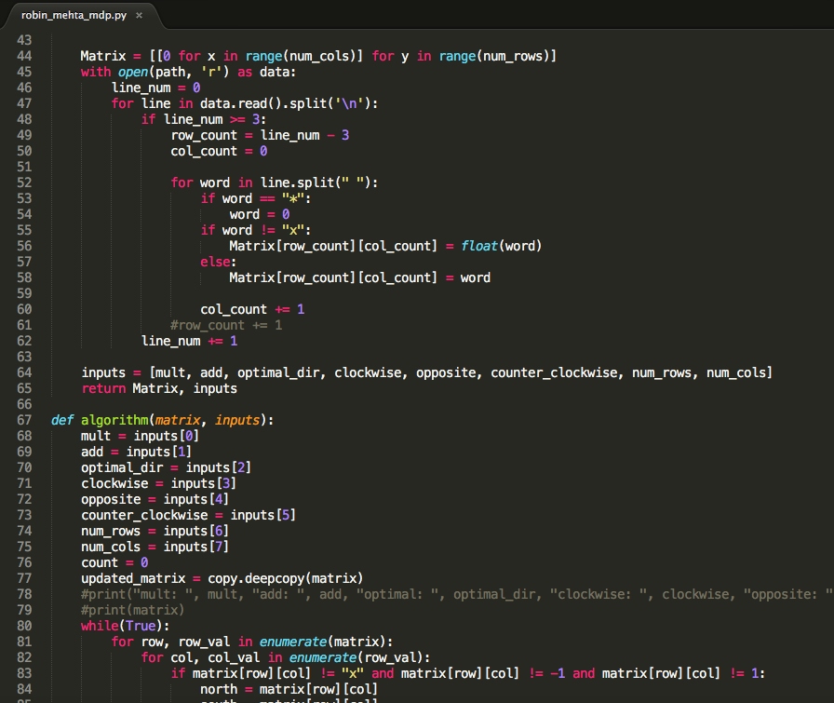

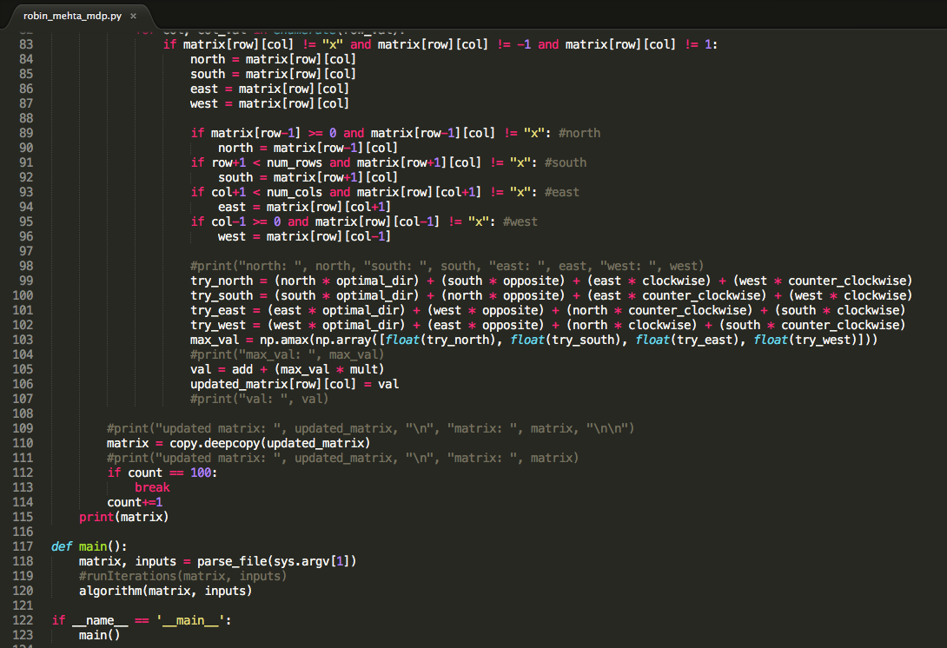

LINEAR REGRESSION / GRADIENT DESCENT:

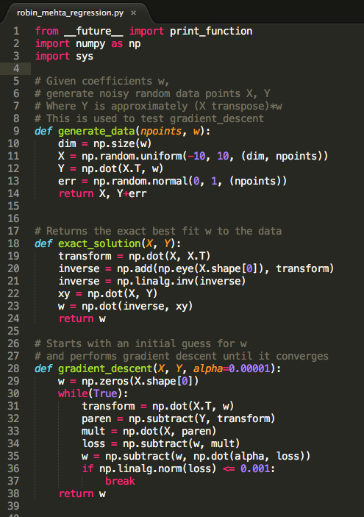

EXTRA CREDIT:

